**Health Visiting and School Nursing Advice Line 0-19 Years**

**0161 835 6789**

Available Monday to Friday 9.00am – 4.30pm

(excluding Bank Holidays)

Support from Health Visitors, Early Years Workers and School Nurses on all aspects of child health development and parenting including:

|  |  |
| --- | --- |
| * Sleep * Introducing family foods and solids * Management of minor illnesses * Speech and communication * General health and emotional wellbeing * Infant feeding * Moving out of nappies * Child development | * + Behaviour   + Immunisations   + Special Educational Needs and Disabilities   + Any issues/concerns about your child’s health   + To book a child health clinic appointment   + Start Well Health Visiting Team contact details   + School Nursing Service   + Signposting to other services |

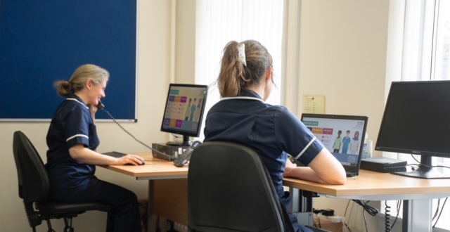

**Useful Websites:**

Understanding your child/Solihull approach course available for free at [**Our Place**](https://eur01.safelinks.protection.outlook.com/?url=https%3A%2F%2Finourplace.heiapply.com%2Fonline-learning%2Fcourses&data=04%7C01%7Cjennifer.ellison%40stockport.gov.uk%7C1fced45f5af549b8cda508d97dd62769%7Ca05ef69e61494fbaa40cdf338810f644%7C0%7C0%7C637679181000153377%7CUnknown%7CTWFpbGZsb3d8eyJWIjoiMC4wLjAwMDAiLCJQIjoiV2luMzIiLCJBTiI6Ik1haWwiLCJXVCI6Mn0%3D%7C1000&sdata=ueuwGhk03hRRKle4%2FPSXoVI2Zka7%2BuH0jFCoTzK%2Bn8U%3D&reserved=0) Use the access code: **REDROCK**

[**www.startwellstockport.co.uk**](http://www.startwellstockport.co.uk) [**www.bbc.co.uk/tinyhappypeople**](http://www.bbc.co.uk/tinyhappypeople)